**Salesforce.com**

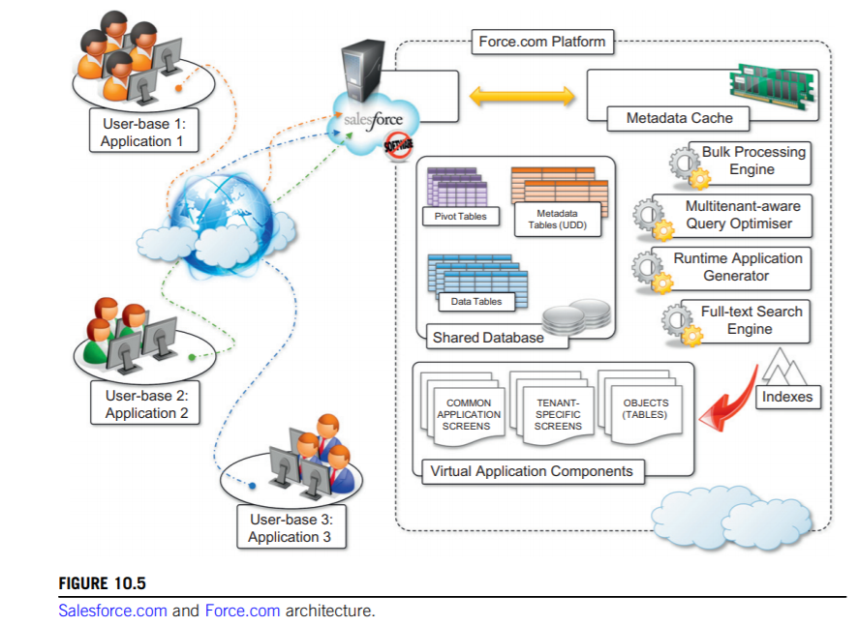

Salesforce.com is probably the most popular and developed CRM solution available today.

Salesforce.com is based on the Force.com cloud development platform.

The architecture of the Force.com platform is initially designed to support scalable CRM applications.

At the core of the platform resides its metadata architecture, which provides the system with flexibility and scalability. Rather than being built on top of specific components and tables, application core logic and business rules are saved as metadata into the Force.com store. Both application structure and application data are stored in the store.

A runtime engine executes application logic by retrieving its metadata and then performing the operations on the data. Although running in isolated containers, different applications logically share the same database structure, and the runtime engine executes all of them uniformly.

A full-text search engine supports the runtime engine. This allows application users to have an effective user experience despite the large amounts of data that need to be crawled. The search engine maintains its indexing data in a separate store and is constantly updated by background processes triggered by user interaction.

Users can customize their application by leveraging the “native” Force.com application framework or by using programmatic APIs in the most popular programming languages. Customization of application processes and logic can also be implemented by developing scripts in APEX. This is a Java-like language that provides object-oriented and procedural capabilities for defining either scripts executed on demand or triggers. APEX also offers the capability of expressing searches and queries to have complete access to the data managed by the Force.com platform.